# Introduction

The Ivy Joystick is intended to be a wearable / graspable device for those with limited gross motor control and limited hand dexterity.

# Research

## Existing Commercial Options

Wii Nunchuck

<https://en.wikipedia.org/wiki/Wii>

<https://en.wikipedia.org/wiki/Wii_Remote>

Wii Nunchuck (RVL-004)

* Analog stick
* Octagonal movement restriction
* Two trigger buttons
* Three-axis accelerometer
* 113 mm long x 38 mm wide x 37 mm thick

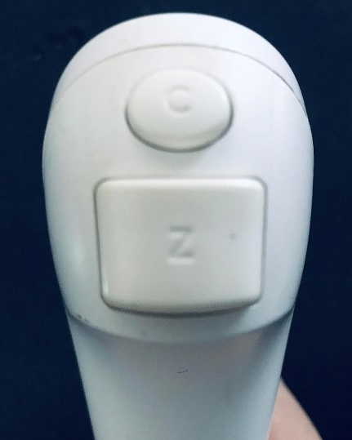

Figure 1 Nintendo Wii Nunchuck. Born2BGod, CC BY-SA 4.0 <https://creativecommons.org/licenses/by-sa/4.0>, via Wikimedia Commons

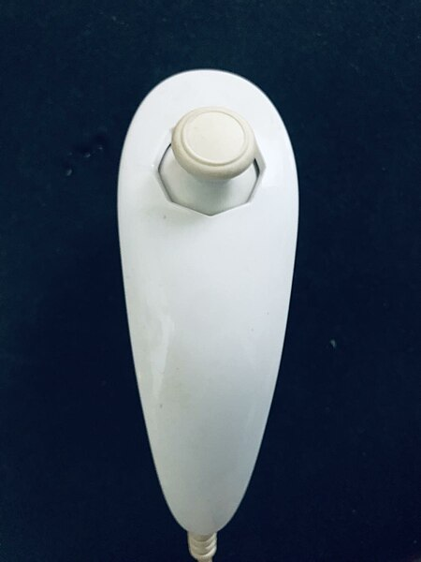

Figure 2. Wii Nunchuck top. Born2BGod, CC BY-SA 4.0 <https://creativecommons.org/licenses/by-sa/4.0>, via Wikimedia Commons

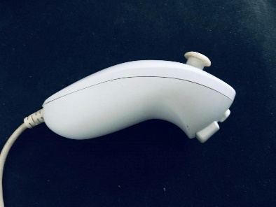

Figure 3. Wii Nunchuck Side. Born2BGod, CC BY-SA 4.0 <https://creativecommons.org/licenses/by-sa/4.0>, via Wikimedia Commons. https://commons.wikimedia.org/wiki/File:Nunchuck_Side.jpg.

|  |  |
| --- | --- |
| Title | PDP One-Handed Controller |
| Link | <https://www.microsoft.com/en-ca/d/pdp-one-handed-joystick-for-xbox-adaptive-controller/8qhw8mlwpp1l> |
| Cost | Discontinued |
| Notes | This is one of the only joystick accessories listed with the Xbox Adaptive Controller. Unfortunately it is no longer available. |

## DIY Designs

|  |  |
| --- | --- |
| Title | USB Mouse Made Out of a Wii Nunchuck |
| Link | <https://www.instructables.com/USB-Mouse-Made-Out-Of-A-Wii-Nunchuck/> |
| Author |  |
| License | CC BY-NC-SA |
| Cost |  |
| Notes | This build requires permanent modification of the Nunchuck. The built-in board on the Nunchuck is disconnected and removed and the buttons and joystick are connected to a Teensy microcontroller. |

|  |  |
| --- | --- |
| Title | Nunchuck Mouse |
| Link | <https://www.instructables.com/nunchuck-mouse/> |
| Author | Krayzi99 |
| License | CC BY-NC-SA |
| Cost |  |
| Notes | This build uses a Nunchuck with a Bluetooth adapter and software that translates the information into mouse commands. |

|  |  |
| --- | --- |
| Title | USB Wiichuck Mouse Using an Arduino Leonardo |
| Link | https://www.instructables.com/USB-Wiichuck-Mouse-Using-an-Arduino-Leonardo/ |
| Author |  |
| License | CC BY-NC-SA |
| Cost |  |
| Notes |  |

|  |  |
| --- | --- |
| Title | Programmable ambidextrous joystick mouse |
| Link | <https://hackaday.io/project/174547-programmable-ambidextrous-joystick-mouse> |
| Author | NDB |
| License | n/a |
| Cost | n/a |
| Notes | Early conceptual design. |

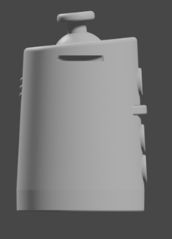

* 3 buttons
* Vibration feedback
* Configuration application

|  |  |
| --- | --- |
| Title | Joytojoy |
| Link | <https://hackaday.io/project/186678> |
| Author | Julien Oudin |
| License |  |
| Cost |  |
| Notes | Gyro-based joystick intended to mount on top of a user’s powerchair joystick. |

|  |  |
| --- | --- |
| Title | One Handed Keymouse |
| Link | https://hackaday.io/project/7254-one-handed-keymouse |
| Author | Patrick Tait |
| License | Software: BSD; CC-BY |
| Cost |  |
| Notes |  |

|  |  |
| --- | --- |
| Title | 3D Printed Joystick |
| Link | <https://hackaday.io/project/172309-3d-printed-joystick> |
| Author |  |
| License |  |
| Cost |  |
| Notes | Uses an LED, fiber optic cables, and a camera to measure different amounts of light that are transmitted in response to 3d printed joystick components. |

|  |  |
| --- | --- |
| Title | Eyemech Controller |
| Link | <http://www.nilheim.co.uk/latest-projects-and-blog/eyemech-controller> |
| Author | Will Cogley |
| License | Unknown |
| Cost |  |
| Notes | 3D printable, handheld device |

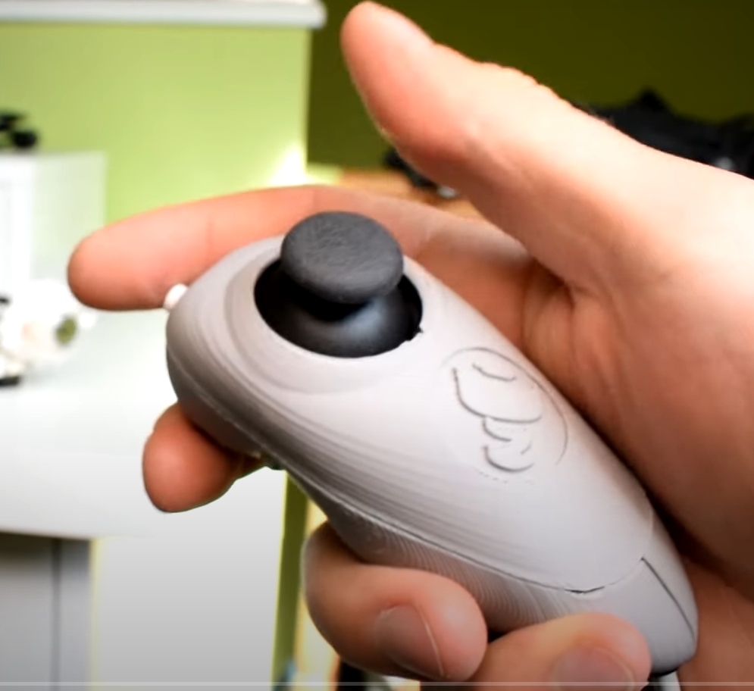

Figure 4 Eyemech Controller. (C) Will Cogley.

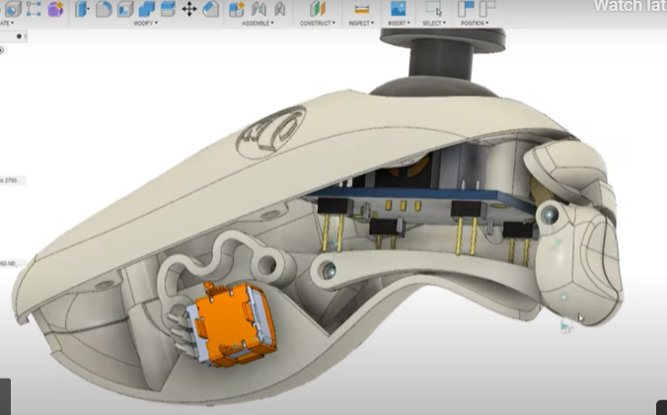

Figure 5. Eyemech controller CAD Model. (C) Will Cogley

|  |  |
| --- | --- |
| Title | USB Nunchuck Mouse |
| Link | <https://hackaday.io/project/188294-usbnunchuckmouse> |
| Author | Esp32beans |
| License | Unknown |
| Cost | Nunchuck: $12.50 USD; Breakout: $2.50 USD; $12.50 USD |
| Test Build (Y/N) | Y |
| Add to Library (Y/N) | TBD |
| Notes | Uses nunchuck clone and Adafruit interface board (<https://www.adafruit.com/product/4836>). |

# Ideation

## Architecture

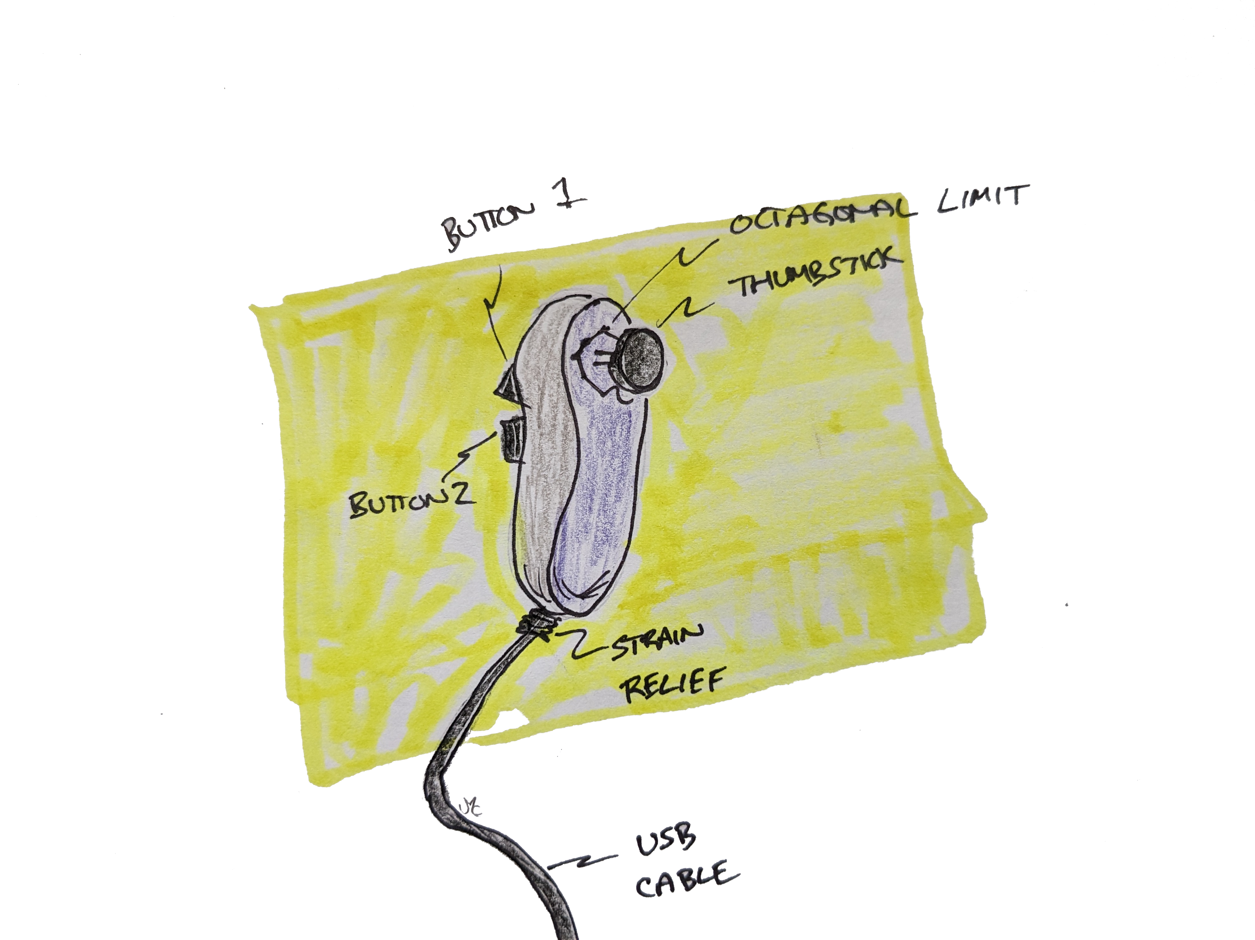

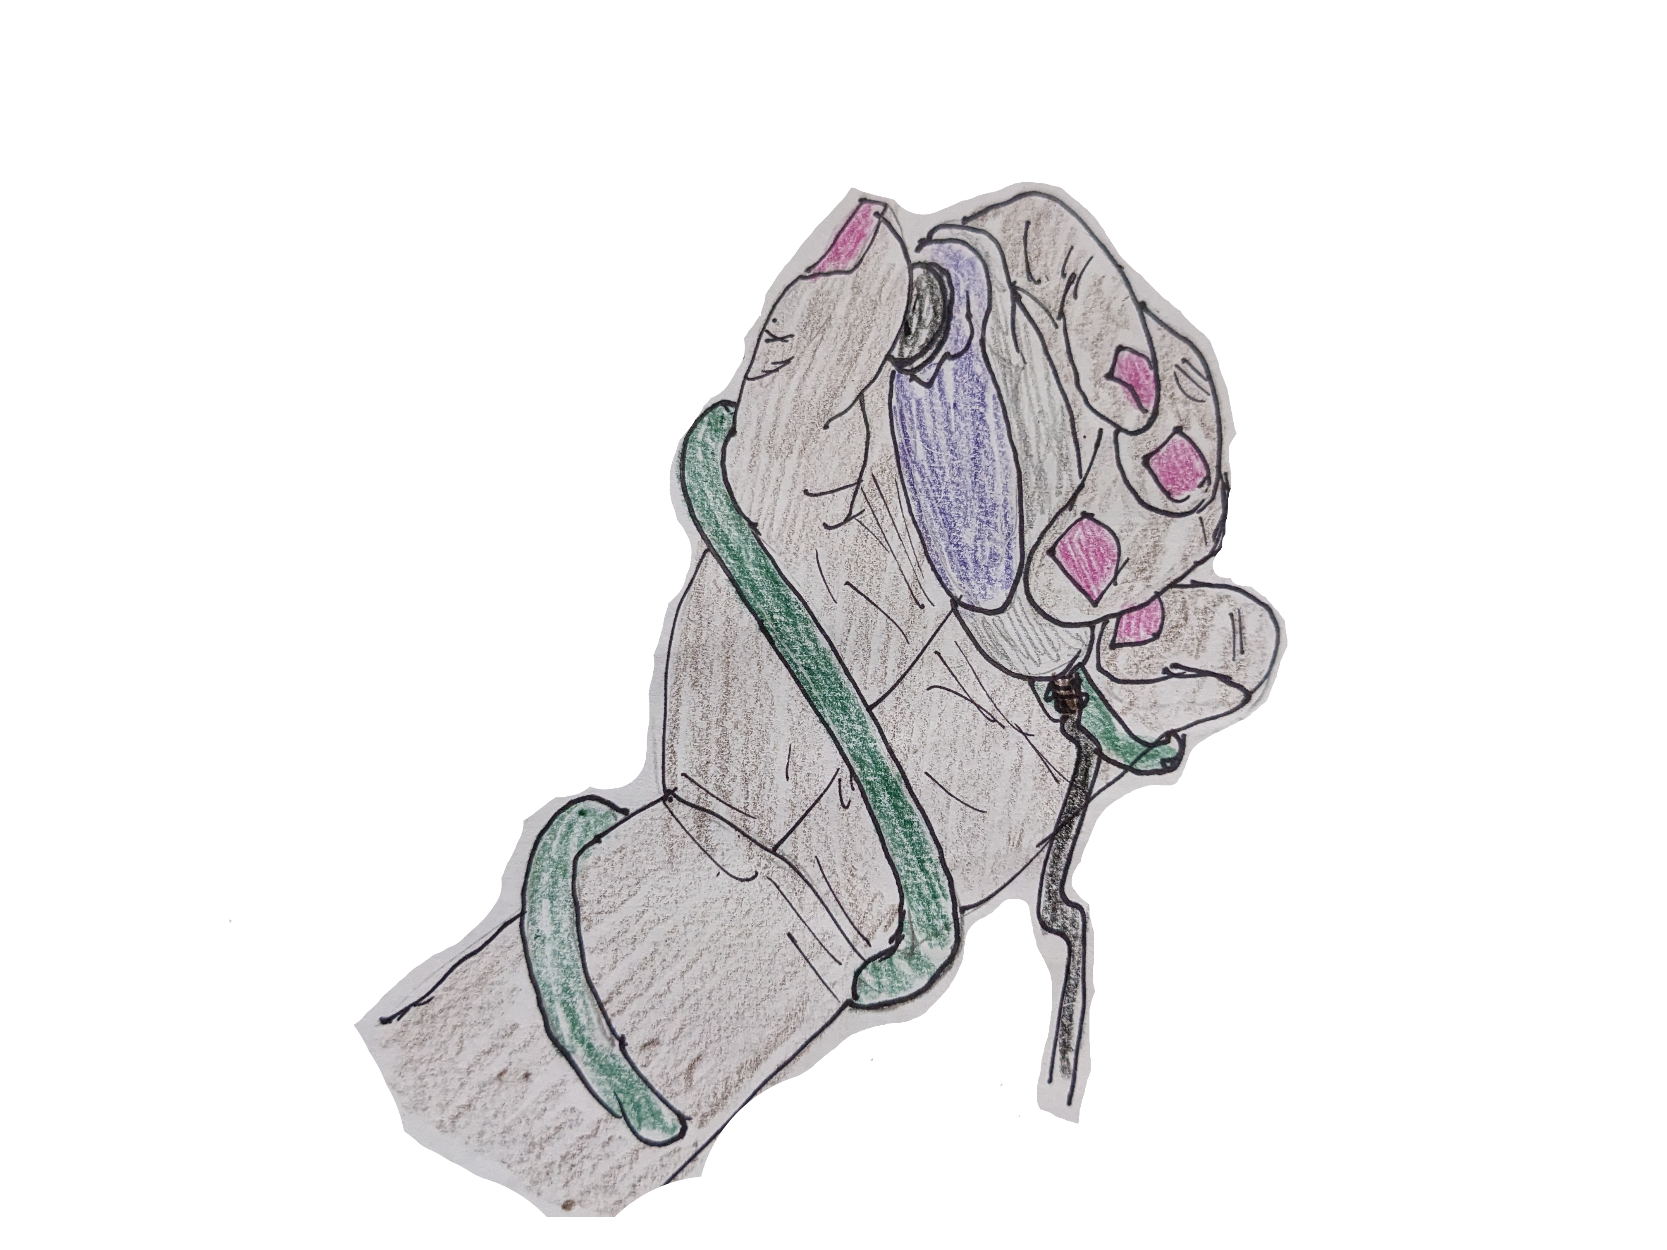

## Commercially Available Joystick Modules

What type of joystick element makes the most sense?

Commercial joystick elements

* PS2 Thumbstick
* Sliding thumbstick
* Nintendo Joycon style thumbstick
* Custom Joystick Element

### Parallax 2-Axis Joystick

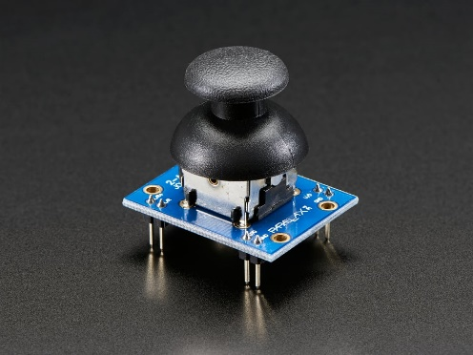

<https://www.parallax.com/product/2-axis-joystick/> - $7.95 USD

<https://www.adafruit.com/product/245> - $9.95 USD

* Dual 10K potentiometers
* > 10 degree deflection: 130 ± 80 gf

### Analog 2-axis Thumb Joystick with Select Button + Breakout Board

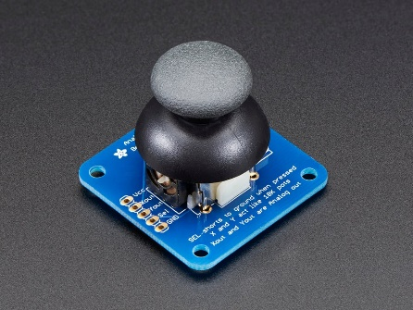

<https://www.adafruit.com/product/512> - $5.95 USD

### PSP 1000 2-Axis Analog Thumb Joystick

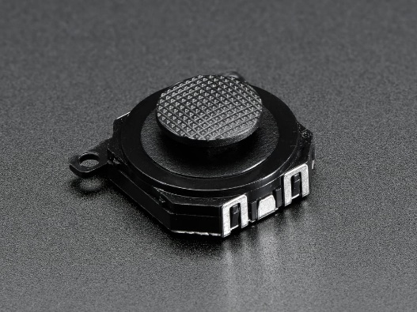

<https://www.adafruit.com/product/444> - $3.50 USD

* self centering
* analog
* dual 10K potentiometers
* replacement for P2P1000

Digikey: <https://www.digikey.ca/en/products/detail/adafruit-industries-llc/444/10669822>

(Backorder as of 2023-Jun-07)

Mouser: <https://www.mouser.ca/ProductDetail/Adafruit/444?qs=GURawfaeGuAZ6SOGY8ImUw%3D%3D>

### PSP 3000 2-Axis Analog Thumb Joystick

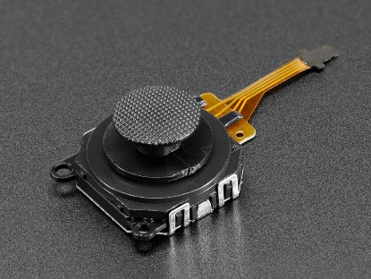

<https://www.adafruit.com/product/3103> - $4.95 USD

DigiKey:

* dual potentiometers
* self centering
* PSP 3000 replacement

Connection

* Requires connector breakout board:
* 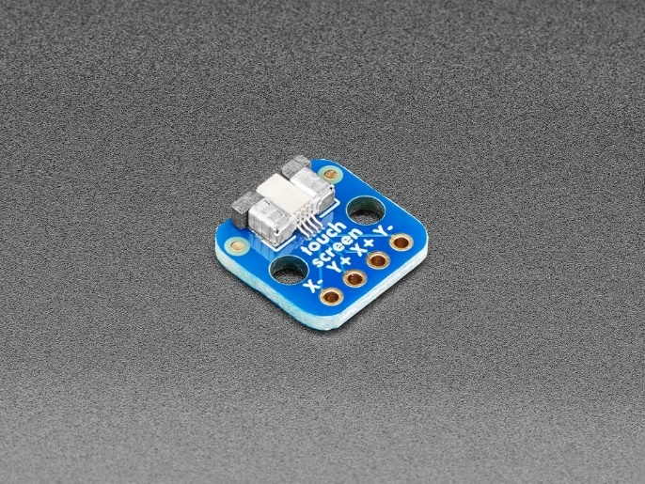
* Adafruit: <https://www.adafruit.com/product/334> - $3.95
* Mouser: <https://www.mouser.ca/ProductDetail/Adafruit/3103>
* Digikey: <https://www.digikey.ca/en/products/detail/adafruit-industries-llc/3103/6193574>
* Cable is installed upside down

**FPC-4P PCB**

[https://www.amazon.ca/MECCANIXITY-Converter-Socket-2-54mm-Printer/dp/B09VPJSXY5](https://www.amazon.ca/MECCANIXITY-Converter-Socket-2-54mm-Printer/dp/B09VPJSXY5/ref=sr_1_1?crid=1IVTGQTTTNY7Y&keywords=FPC-4p+pcb&qid=1686122573&sprefix=fpc-4p+pcb%2Caps%2C132&sr=8-1)

5 pack for $9.99

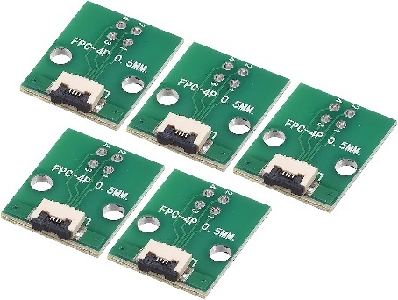

[Ron Nelson (4 for $15.99)](https://www.etsy.com/ca/listing/1349068687/diy-joycon-breakout-board-set-of-4?click_key=7b46501a376b3fb6469448e4f85eb0b8be58d1bd%3A1349068687&click_sum=7dbbedfa&ref=shop_home_active_2&crt=1&sts=1)

### Mini 2-Axis Analog Thumbstick

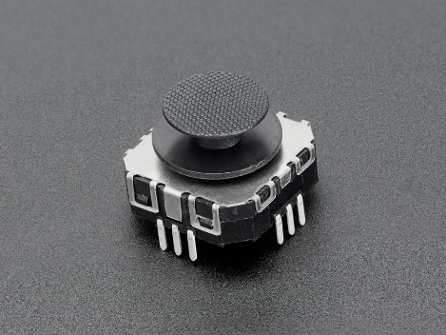

<https://www.adafruit.com/product/2765> - $2.50 USD

<https://www.digikey.ca/en/products/detail/adafruit-industries-llc/2765/6193582>

* Optional breakout board: <https://www.adafruit.com/product/3246>

### Mini Analog Thumbstick - Similar to Joycon Style

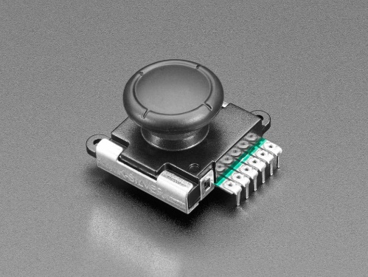

<https://www.adafruit.com/product/5628> - $4.50 USD - Out of stock 2023-06-22

* Similar, but not replacement for Nintendo Joycon
* Self centering
* Dual 10K potentiometers

Digikey: Not available as of 2023-06-07

Mouser: Not available as of 2023-06-22

### Joycon Replacement

<https://www.amazon.ca/Jeylly-Original-Joystick-Replacement-Controller/dp/B08B4K4NCV>

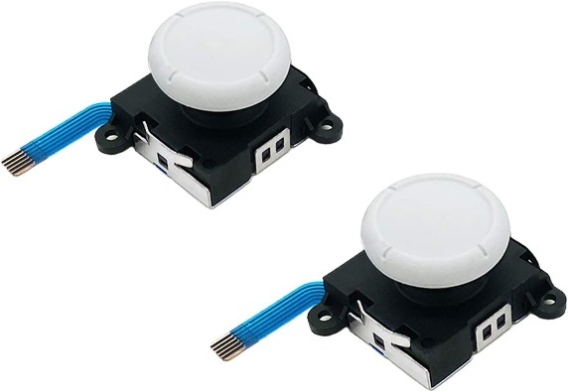

Guiliket Hall effect joycon:[**https://www.gulikit.com/productinfo/945307.html**](https://www.gulikit.com/productinfo/945307.html)

### SparkFun Qwiic Joystick

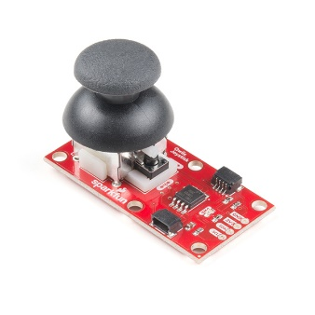

Figure 6: SparkFun Qwiic Joystick CC BY 2.0 Sparkfun.

<https://www.sparkfun.com/products/15168> - $11.50 USD

[Digikey](https://www.digikey.ca/en/products/detail/sparkfun-electronics/COM-15168/9953917)

* dual 10K potentiometers
* single i2c address; requires multiplexer for multiple units on same bus

### Thumb Joystick

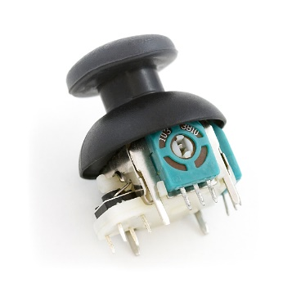

Figure 7. Thumb Joystick. (C) Sparkfun. CC BY 2.0.

<https://www.sparkfun.com/products/9032> - $4.50 USD

* dual 10 pots
* self-centering
* push button
* breakout board: <https://www.sparkfun.com/products/9110> - $2.10 USD

### Thumb Slide Joystick

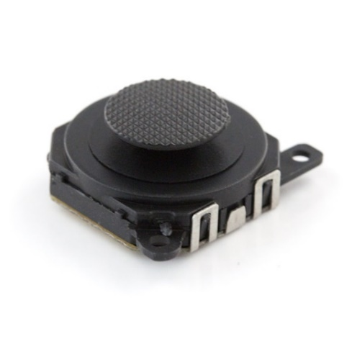

Figure 8. Thumb Slide Joystick. Image (C) SparkFun, released under CC BY 2.0

* Similar to PSP1000

<https://www.sparkfun.com/products/9426-> $3.95 USD

### Thumb Joystick – Deluxe

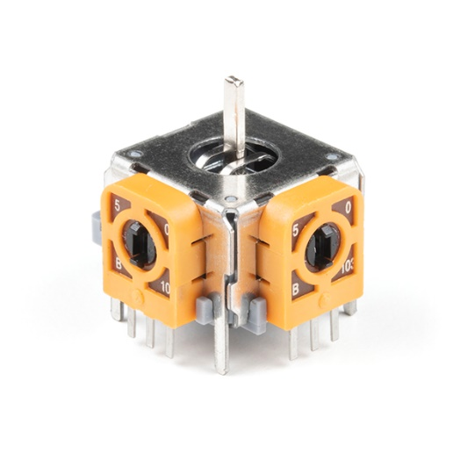

Figure 9. thumb Joystick - Deluxe. (C) Sparkfun, released under CC BY 2.0

* COM-16273
* Requires Thumb Joystick Knob – Deluxe <https://www.sparkfun.com/products/17263> - $1.05 USD
* Dual 10K potentiometers

### ANO Directional Navigation and Scroll Wheel Rotary Encoder

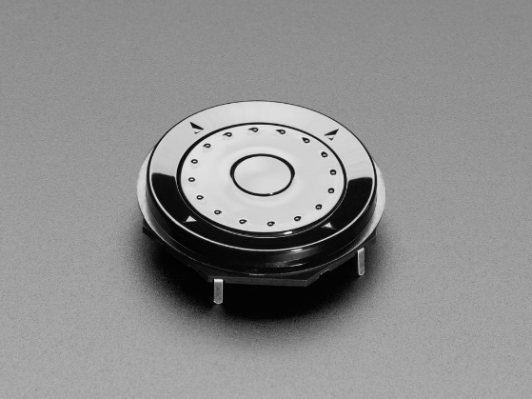

<https://www.adafruit.com/product/5001>

### Thru-hole 5-way Navigation switch

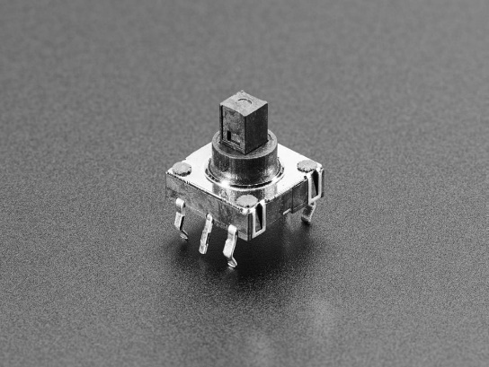

[**https://www.adafruit.com/product/504**](https://www.adafruit.com/product/504)

## Modular Mounting Connection

* separate handle portion
  + allows for customized sizes / colours / etc
  + more printable
* dove tail connection between main body and handle

## Design Elements

* Removable handle
* Finger grooves / Grip
* How to accommodate different sized hands
  + Two part
  + Instamorph?
  + Shrink wrap?
  + Bike wrap?
  + Dycem
  + Uva foam
  + Foam sheets
* How to affix sheets?
  + Clamps
  + Glue

## Assembly

* Two piece clam shell
* Three piece
  + Right
  + Left
  + Top
  + Screws + a couple locating pins

Affixing joystick into enclosure

* Conical print
* Screws
* Snap-fit

## Tactile Feedback

Could a tactile feedback element be added here?

e.g., i2C Haptic Driver controller + Haptic motor.

## Button Options

* Integrated buttons
* Integrated switch jacks

## Mounting

* Flexible tie wrap mounting – e.g., wrapping around arm like ivy
* Modular – integration with cuff style
* Interface with Instamorph for custom fit

# Conceptual Design

## Concepts

1. Utilizing commercially available Nunchuck controller from Nintendo or a knock-off.
2. Novel 3D printed Nunchuck-style controller

Nunchuck controllers and knock-offs are readily available via Amazon and electronics suppliers, are fairly cost effective ($12-15 CAD ea.), and may also be available at little to no cost used. The controller features a thumbstick, two buttons, and an embedded accelerometer.

## Nunchuck Concept

Summary: Utilize an existing Nintendo Nunchuk or equivalent in addition to Adafruit Breakout board + Microcontroller.

### Architecture

1. Utilize Nunchuck (or knock-off) as-is, mount interface electronics in stand-alone box.
2. Open Nunchuck (or knock-off) and embed interface electronics within existing enclosure.
3. Extract electronics from Nunchuck (or knock-off) and incorporate into custom enclosure

#### Stand-alone Box

This is the simplest approach. It does not require any modification to the existing controller. Basic assembly can also be completed without the use of soldering by utilizing a STEMMA QT cable with the Nunchuck Breakout board and a development board cwith a STEMMA QT connection (e.g., Adafruit SAMD21 QtPy).

#### Embedded Electronics

This approach requires the Nunchuck to be disassembled, permanently modified, and then reassembled.

Disassembling the Nunchuck require a small Phillips screwdriver (i.e., No. 0) to remove the two small screws holding the two parts of the enclosure together. The existing cable assembly consists of 5 wires and a molded in strain relief. The wires would need to be cut and soldered either directly to the microcontroller development board or to the pads on the Nunchuck breakout board. The is some available space within the enclosure, but not quite enough to accommodate the QtPy board with a standard USB-C cable to use the existing cable hole. It looks like some of the inner support ribs could be cut to provide sufficient space for the dev board and cable.

The other option here would be to remove the existing i2C circuitry and connect the joystick and buttons directly to the microcontroller. It also unclear how much variation may exist between Nunchuck controllers from different manufacturers.

#### Incorporated components

This approach involves disassembling a Nunchuck controller, removing the electronics components and incorporating them into a different enclosure.

It’s not known how consistent the internals are between models of the Nunchuck from different suppliers.

### Nunchuck Mounting

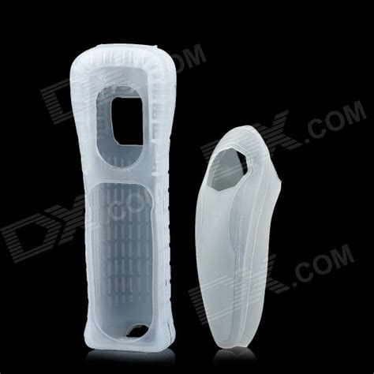

Mounting Ideation

* Commercially available silicon sleeve
* 3D Printed Add-on?
* Interface with mounting screw
* Instamorph?

### Circuitry

The Nunchuck controller uses an i2C interface with a proprietary connector. Interfacing with the circuitry could happen within the Nunchuck enclosure, by cutting the cable, or by using a suitable adapter with the connector.

### Code

There is an existing open source library, the WiiChuck Library, for interfacing with the controller.

<https://github.com/madhephaestus/WiiChuck>

LGPL-3.0 License

## Novel 3D Printed Enclosure

Summary: Create a novel enclosure with electronic elements similar to the Nunchuck controller.

# Novel Nunchuck-like Enclosure Concept

## Components

### Amazon Joycon Replacement Joystick

Jeylly Original 3D Analog Joystick Joy-Con Replacement Left/Right Repair Kit Thumb Sticks Sensor with 4 “Y” Screws for Nintendo Switch Joycon Controller and Switch Lite Console - 2 Pack White <https://www.amazon.ca/dp/B08B4K4NCV> - $11.23

* This is intended as a replacement for the thumbstick in the Joycon controller. It is not the same part as the [Adafruit PSP 3000 2-Axis Analog Thumb Joystick](https://www.adafruit.com/product/3103)
* The cable is intended to be used with a Zero Force Insertion (ZIF) connector it a 5P 0.5 mm pitch connector.
* The connector does not fit the [Adafruit Touch screen breakout board (0.5mm FPC)](https://www.adafruit.com/product/334)
* The connector does not fit the other 0,5mm FPC connector from Amazon.
* It has two two ~1.6 mm holes; M1.7 screws were too big; M1.4 screws fit okay; the joycon is connected to the joycon controller with two 3.5 mm Phillips #00 screws[1].
* Surface mount connector: <https://www.mouser.ca/ProductDetail/Amphenol-FCI/59453-051110ECHLF?qs=SqJKR5Mmryc5fGwXZgOgcA%3D%3D>
* It doesn’t appear as though any 0.5 mm pitch, 5 position connectors are available in thru hole format or as a breakout board.

Protoboard:

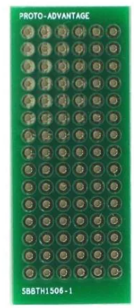

<https://www.mouser.ca/ProductDetail/Chip-Quik/SBBTH1506-1?qs=gjT6naH6P5K7JrxFPe%252BjSQ%3D%3D>

## Electrical Connections

### Protoboard

Universal Proto-board PCBs 4cm x 6cm - 3 Pack

* <https://www.adafruit.com/product/4785>
* 3 pack
* 4 cm x 6 cm

Universal Proto-board PCBs 3cm x 7cm

* 3-pack: <https://www.adafruit.com/product/4784>
* 3 cm x 7 cm
* Can score with hobby knife and ruler and break to size

### 3D Printed Circuit Board

Flexible Protoboard

<https://www.adafruit.com/product/3904e.g>. <https://www.adafruit.com/product/3904>

20cm x 30 cm

Adafruit Flex Perma-Proto - Half-sized Breadboard Flex-PCB

* <https://www.adafruit.com/product/1518>
* 79 mm x 43 mm

## Concept Selection

The Nunchuck Concept with the Stand-alone box architecture was selected for development in to the MVP. It provides a simple, solderless way to create a controller, the parts are readily available and components are cost-effective. The biggest limitation is that standard Nunchuck conrollers only have two buttons.

# Ivy Nunchuck Joystick Adapter V0.1

## Electronics

### Electronic Components

This approach requires a Nunchuck Breakout board and an i2C-compatible microcontroller. The Adafruit QTPY SAMD21 was selected as it cost effective, readily available, has an interchangeable footprint with other microcontrollers and has a built in STEMMA QT connector.

### Circuitry

This circuitry is simple; the Nunchuck Breakout board must be attached to the microcontroller via a STEMMA QT cable.

## Key Functions

Need a way to operate in mouse mode and joystick mode.

## Enclosure

The enclosure must securely hold the microcontroller and the Nunchuck breakout board.

### Nunchuck Controller Clearance / Knockout

The enclosure must have adequate clearance to allow the Nunchuck controller to be attached. See measured dimensions below.

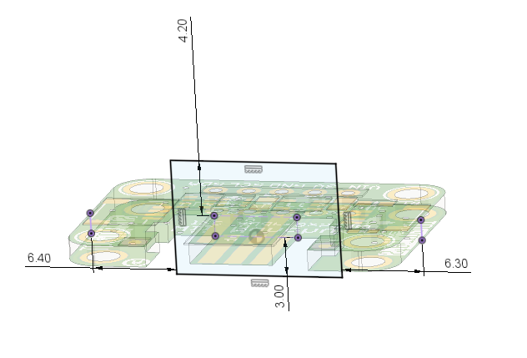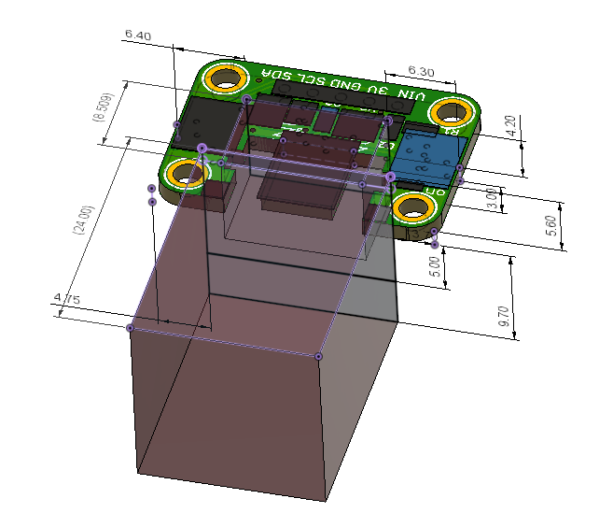

### Component Arrangement

Two arrangement were considered: an inline arrangement with Nunchuck connection on one side and USB connection on the other side, and a single sided arrangement with both connections on the same side. The in-line arrangement was selected in attempt to better manage cables, and provide a logical flow as an ‘adaptor’.

### Electronic Component Mounting

To reduce the number of components, cost, and build complexity, the electronics were attached into the enclosure without the use of fasteners. The Adafruit QTPY board was secured with snap fit elements and the Nunchuck breakout board was secured using posts through the mounting holes. Ideally only one method would be used, but QTPY board does not have mounting holes and there was insufficient room on the edges of the breakout board to allow for snap-fits.

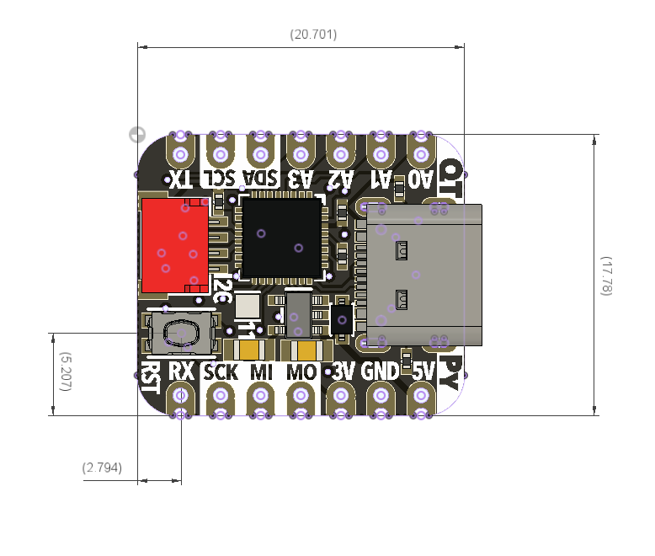

### Enclosure Architecture

Again, to minimize the number of tools and components required, the enclosure was designed to use snap fits to attach the top part of the enclosure to the bottom part of the enclosure. A two-piece enclosure provides for easy assembly.

### Enclosure Features

The enclosure features a print-in-place flexible element for pressing the reset button on the microcontroller. It also features a hole for a light pipe so the LED on the microcontroller can be viewed from the outside of the enclosure.

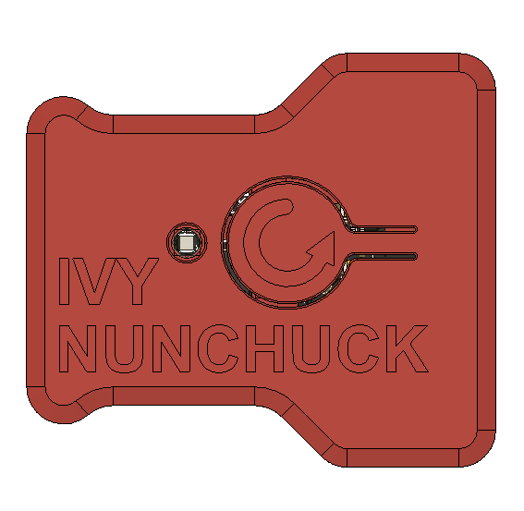

Figure 10 V0.1 Enclosure Top View

A third component was created to help cover the USB-C connection due. This thin oval shaped ring is placed on to the USB connection on the microcontroller to help reduce the gap between the enclosure and the USB connection that would otherwise be difficult to achieve with 3D printing tolerance and print orientations.

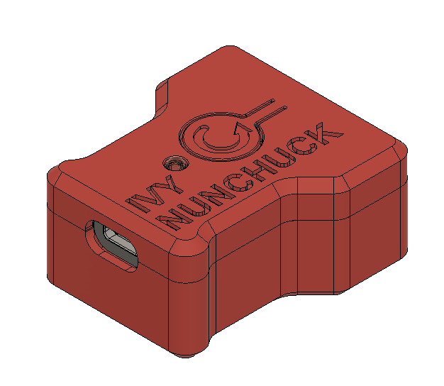

Figure . Isometric view of enclosure showing USB connection side.

## Software

The software was based on previous work developed for the OpenAT Joysticks. That software was modified to utilize the WiiChuck library for managing communication to the Nunchuck Controller.

Some progress was made towards an integrated object-oriented approach to managing different types of joystick sensors. A JoystickInput class was created with derived classes for different types of Joystick Input devices like potentiometers, Hall effect, and the Nunchuck.

## Testing

### Research Questions

* Ability to switch between mouse and joystick
  + Different code / code flags
  + Add slide switch?
* Third button for mouse / scroll?
  + Accelerometer / gryo
  + Activated with both buttons
    - Toggle
  + Add switch jack to box
* Mounting?
* Do we need the USB cover component? Can this be made more printable?
* Need / alternatives for light pipe?

## Naming

NUNCHUCK is still a registered trademark in Canada owned by Nintendo.

Nunchuck is not registered as a trademark in Canada or the US.

## Opportunities for Improvement

1. Add labels to input / output connections
2. Further investigate naming options
3. Create a soldered version
   1. Add a slide switch to change mode
   2. Add 1 or more switch jacks
4. Investigate methods to add scroll functionality
   1. E.g., Button 1 and Button 2 simultaneously, Button sequence
5. Add additional control Modes (e.g. accelerometer based cursor control)
   1. IMU for cursor control; joystick for scroll (or buttons?)
6. Second joystick via i2c Seesaw?
7. Investigate additional mounting options
8. Research existing topper designs and/or develop toppers designs for Nunchuck Controller thumbstick
9. Detail and test the different adapter options for connecting to different consoles / host devices.
   1. Mayflash to connect with Nintendo Switch
10. Code to handle disconnected Nunchuck
11. Code / physical method to disable mouse output in case something goes wrong with code.
12. Investigate options for creating an analog version of the Nunchuck.
    1. E.g. Nunchuck controller, TRRS cable, 2X mono cables.
13. Implement mouse acceleration
14. Implement input switch debouncing

1. <https://www.ifixit.com/Guide/Left+Joy-Con+Joystick+Replacement/113182>